|  |  |
| --- | --- |
|  | **AMERICAN INTERNATIONAL UNIVERSITY – BANGLADESH (AIUB)**  **Faculty of Science and Technology (FST)**  **Department of Computer Science** |
| **Course Name**: Data Structure (Theory) **Section**: [F] **Semester:** Fall 2020-2021  **Submission Date:** 18.12.2020 **Term:** Final-Term **Faculty Name:** Mahfujur Rahman | |

1. Perform ***preorder, inorder*** and ***postorder*** traversal for the following tree and write the node sequence for each traversal. **Marks: 10**

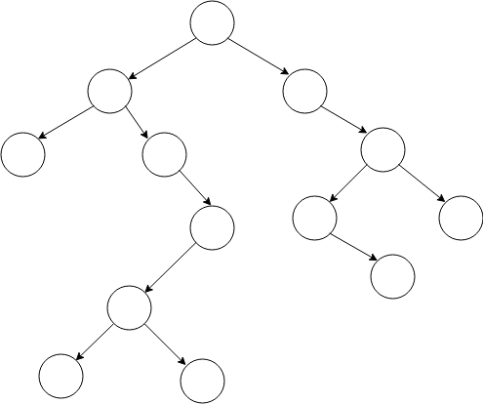

1. Draw a **BST** from the array: **{85, 82, 500, 70, 525, 55, 90, 107, 93, 511, 517}.** Now, show the simulation for **deleting** the node with the value **500.** **Marks: 10**

**Instructions For Preparing Your Quiz:**

- Your quiz document must be in the form of **handwritten hard copy**, not the typing copy.

- You can use a **scanner to create a PDF file** of your completed handwritten quiz document, or you can **use your smartphone to take images of your work that can be compiled in a Word document and convert it into PDF.** Please check the video tutorial who cannot understand how to make a PDF.

~ Scanner: (<https://www.youtube.com/watch?v=fPp8Ox7qfCM>)

~ Images: (<https://www.youtube.com/watch?v=5K7xxQ8np90>)

- Rename the PDF as your student ID _ DS _ Q3 _ Final _ Sec **(Example: 19-12345-2_DS_Q3_Final_F.pdf)**

- **Copy and paste is prohibited.** I will check everyone's assignment carefully.

- **Submit the quiz document on 18 December 2020 (Friday) 08:45 PM.** **Deadline will be strictly followed** and marks will be deducted who misses submission deadline.

- You must **add a cover page.** The key contents of your cover page should be (Course Title, Submission Type [e.g. Quiz-3 ~ Final-Term], Your Name, ID, Section & Department).

**Instructions For Submitting Your Quiz:**

1. Complete all the tasks and create a PDF of your Quiz.
2. ​Rename the PDF as your studentID_DS_Q3_Final_Sec (Example: 19-12345-2_DS_Q3_Final_F.pdf)
3. Attach the file here **(Add Work).**
4. **Turn in / Hand in.**
5. **Submit the quiz on 18 November 2020 (Friday) 08:45 PM.**
6. For Submission Instruction, please check the video tutorial (https://www.youtube.com/watch?v=hgJAUupKkfM)